Nepal College of information Technology
Imadol lalitpur
Assessment Spring Semester 2006

Program : BE Semester: Spring
Time : 2hrs Year : 2006
Full Marks: 100
Engineering Math-II
Attempt all questions

1. a) Find the distance from the point (3,4,5) to the point where the line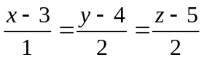 meets the plane x + y + z = 2 7
Or
Find the shortest distance between the lines
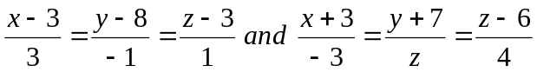
b) Obtain the equation of the sphere through (1,0,0) (0,1,0) (0,0,1) and its radius as small as possible. 8
2. a) Find 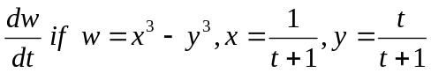
b) If 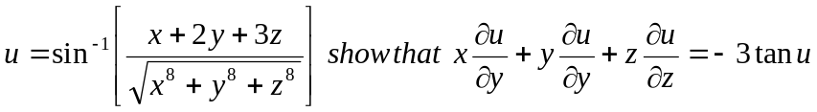
3. a) Sketch the solid in the Ist octant bounded by the cources and find its volume: x² _{+z}² =9, y = 2x, y = 0, z = 0 8
Or
Evaluate reversing the order of integration 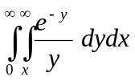
b) Change the Cartesian integral into polar integral & evaluate: 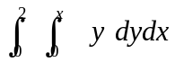 7
4. a) Solve 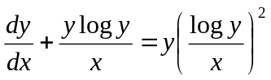 7
b) y¹¹¹+ 3y¹¹ ₊ 3y¹ =+ 30e^{-x} 8
Or
y" - y' = x⁴
5. a) y" + 2y' + y = e^{-x} cosx
b) By power service method solve xy' - 3y = 9 8
Or
Show that 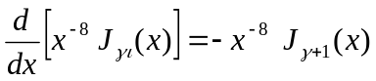
6. a) Define Lap lace transform f(t). Find Inverse transform of 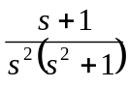
b) Solve the initial value problem by using Lap lace transform
y" + 2y' + 5y = 0 , y(0) =2 y'(0) = - 4 7
7. Attempt all:- 5*2=10

i) If V = f(xyz), show that x² V_{xx} = y² V_{yy} = z² V_{zz}
ii) Find Lap lace transform of u_{a} (t).
iii) Evaluate 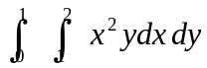
iv) Solve e^{y-x} dx + e^{x-y dy} = 0
v) Find Integrating factor of (y+1) dx = (x+1) dy.

